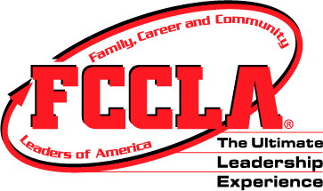
FCCLA Chapter Membership Application

Name:

Address:

City: State: IL Zip: Phone Number:

E-mail: Grade: ____ Teacher: Age: __

I am a: (Circle one)
- New member
- Returning member of ____ years

I am interested in: (Circle all of interest)
- Participating in planned events
  - Community service – ideas?
  - Chapter service
- Fundraising activities: Do you have any ideas of fundraisers? __________________________________________
- Becoming an officer
- Participating in competitive STAR Events

I am willing serve on committees: (circle one) Yes No

I, will remain a member in good standing, attend meetings, get copies of minutes, follow announcements, deadlines and activities of group and wear appropriate clothing to all FCCLA sponsored events.
____
(Student Signature)

Dues $15.00 ($9.00 National & $6.00 State)
Dues paid before Tuesday, September 1, 2015 are only $10!
Dues MUST be paid by Friday, October 31, 2015 in order to participate in State and Nat’l Programs

Date Paid ______ Amount Paid ______ Cash___ Check (Made payable to KHS FCCLA) #

If paid by check, name and information on checking account ____ _______________

**For more information about FCCLA please visit www.ilfccla or www.fcclainc.org

FCCLA Membership Permission Form
Student’s Name Grade____________ has my permission to become a part of ROWVA High School Family, Career, and Community Leaders of America (FCCLA) Chapter.

Parent/Guardian Signature____________________________________________________________Date_____________

